# How to Run Packer Pipelines on Jenkins: Part 1 - Traditional Jenkins

Published: Aug 17, 2021Updated: Aug 23, 2021Share on:

## Table of Contents

* [Blog Series: How to Run Packer Pipelines on Jenkins](https://fabiogomezdiaz.com/posts/how-to-run-packer-pipelines-on-jenkins-part1-traditional-jenkins/#blog-series-how-to-run-packer-pipelines-on-jenkins)
* [Why you need Packer Pipelines on Jenkins](https://fabiogomezdiaz.com/posts/how-to-run-packer-pipelines-on-jenkins-part1-traditional-jenkins/#why-you-need-packer-pipelines-on-jenkins)
* [How to integrate Jenkins with Packer](https://fabiogomezdiaz.com/posts/how-to-run-packer-pipelines-on-jenkins-part1-traditional-jenkins/#how-to-integrate-jenkins-with-packer)
* [Run Packer Pipelines Inside Traditional Jenkins Installation](https://fabiogomezdiaz.com/posts/how-to-run-packer-pipelines-on-jenkins-part1-traditional-jenkins/#run-packer-pipelines-inside-traditional-jenkins-installation)
  + [a. Packer Code Explained](https://fabiogomezdiaz.com/posts/how-to-run-packer-pipelines-on-jenkins-part1-traditional-jenkins/#a-packer-code-explained)
  + [b: Packer Pipeline Explained](https://fabiogomezdiaz.com/posts/how-to-run-packer-pipelines-on-jenkins-part1-traditional-jenkins/#b-packer-pipeline-explained)
  + [c: Setting up Packer Pipeline on Jenkins](https://fabiogomezdiaz.com/posts/how-to-run-packer-pipelines-on-jenkins-part1-traditional-jenkins/#c-setting-up-packer-pipeline-on-jenkins)
  + [d: Running the Packer Pipeline](https://fabiogomezdiaz.com/posts/how-to-run-packer-pipelines-on-jenkins-part1-traditional-jenkins/#d-running-the-packer-pipeline)
  + [e: (Optional) Fix command not found error on Jenkins on macOS](https://fabiogomezdiaz.com/posts/how-to-run-packer-pipelines-on-jenkins-part1-traditional-jenkins/#e-optional-fix-command-not-found-error-on-jenkins-on-macos)
* [Conclusion](https://fabiogomezdiaz.com/posts/how-to-run-packer-pipelines-on-jenkins-part1-traditional-jenkins/#conclusion)

## Blog Series: How to Run Packer Pipelines on Jenkins

In my day job, I’ve had to setup Packer Pipelines on Jenkins multiple times for multiple clients. That’s when I learned that not every Jenkins setup is the same, so I created the **How to Run Packer Pipelines on Jenkins** blog series where you will learn how to setup a Packer Pipeline in the most common Jenkins configurations. Here is the list of all the blogs in the series.

* [How to Run Packer Pipelines on Jenkins: Part 1 - Traditional Jenkins (this post)](https://fabiogomezdiaz.com/posts/how-to-run-packer-pipelines-on-jenkins-part1-traditional-jenkins/)
* [How to Run Packer Pipelines on Jenkins: Part 2 - Jenkins in Docker](https://fabiogomezdiaz.com/posts/how-to-run-packer-pipelines-on-jenkins-part2-jenkins-in-docker/)
* **COMING SOON**: How to Run Packer Pipelines on Jenkins: Part 3 - Jenkins in Kubernetes.

## Why you need Packer Pipelines on Jenkins

Have you tried using Packer to create Operating System (OS) templates? Don’t you hate how do you need to keep your laptop unlocked and it takes forever to run?

While it is easy to run Packer on your workstation to create OS templates, it usually takes a long time to run. That’s why it is best to use Packer inside of an automation server such as Jenkins, on a separate machine.

In this blog entry, you will learn how to setup a Packer Pipeline in a traditional Jenkins installation.

## How to integrate Jenkins with Packer

No matter what Jenkins configuration you have, you can integrate Jenkins with Packer using the following 5 steps:

1. Install Jenkins.
2. Install Packer binary on Jenkins node or Jenkins agent.
3. Write Packer and Jenkins Pipeline code and put it in a Git repository.
4. Setup Jenkins Pipeline Job using Pipeline code from Git repository.
5. Run pipeline.

The details will vary based on your configuration but they will follow the same principles.

## Run Packer Pipelines Inside Traditional Jenkins Installation

This blog will focus on the simplest, though perhaps not the most robust, installation of Jenkins. This is how most people will likely be introduced to Jenkins, so it makes sense to start here. The following is a diagram describing what we are trying to setup:

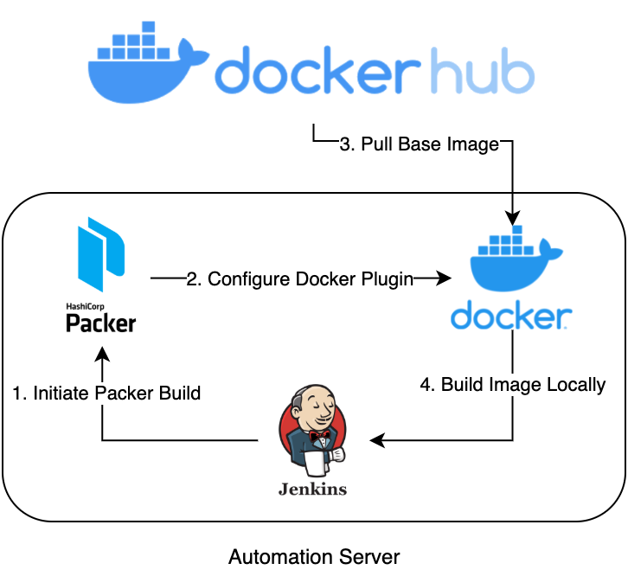

#### Jenkins Pipeline Diagram

Basically, in the same machine, we will be installing Jenkins, Packer, Docker, and run the Jenkins Pipeline that will use Packer to create a container image with Docker. You can do this in your own workstation or on a separate VM or server.

Now, to install everything that we need, click on the links below and follow the instructions for your platform:

* [Jenkins](https://www.jenkins.io/download/).
* [Docker](https://docs.docker.com/get-docker/).
* [Packer](https://www.packer.io/downloads).

### a. Packer Code Explained

**NOTE**: All the code that we will be using today is in my [github.com/fabiogomezdiaz/packer-pipelines](https://github.com/fabiogomezdiaz/packer-pipelines) GitHub repo. So you can follow along or try to replicate this yourself.

Instead of building a Virtual Machine (VM) template, we will be using Packer to build a container image using Docker. We use Docker instead of a Cloud Provider (AWS, Azure, or GCP) account because Docker is free and can be downloaded in your workstation. Besides, the same Packer principles apply to building Docker Images as to building VM images.

The Packer code that we will be using here is from the [Packer - Docker - Build an Image Tutorial](https://learn.hashicorp.com/tutorials/packer/docker-get-started-build-image#write-packer-template). Here is the code:

packer {

required_plugins {

docker = {

version = ">= 0.0.7"

source = "github.com/hashicorp/docker"

}

}

}

source "docker" "ubuntu" {

image = "ubuntu:xenial"

commit = true

}

build {

name = "learn-packer"

sources = [

"source.docker.ubuntu"

]

}

Here is a quick breakdown of what it does:

* The packer block is to configure packer-specific settings.
  + In this case, we need to specify that we will be using the docker plugin.
  + See [Packer block documentation](https://learn.hashicorp.com/tutorials/packer/docker-get-started-build-image?in=packer/docker-get-started#packer-block) for more details.
* The source block in this case is used to configure the docker builder plugin.
  + In our case, the Docker builder configuration creates a new Docker image using ubuntu:xenial as the base image, then commits the container to an image locally.
  + See [Source block documentation](https://learn.hashicorp.com/tutorials/packer/docker-get-started-build-image?in=packer/docker-get-started#source-block) for more details.
* Lastly, the build block defines what Packer should do with the Docker container after it launches, which in our case, it does nothing other than provide a reference to the image defined in the source block.
  + See [Build block documentation](https://learn.hashicorp.com/tutorials/packer/docker-get-started-build-image?in=packer/docker-get-started#the-build-block) for more details.

### b: Packer Pipeline Explained

Now that we have everything setup, let’s take a look at the Jenkinsfile.groovy file, which contains the pipeline code that will be used in Jenkins:

pipeline {

agent any

stages {

stage('Packer - Build Ubuntu Image on vSphere') {

steps {

sh """

#!/bin/bash

cd jenkins-tutorial

packer init .

packer build -force .

"""

}

}

}

}

Basically, it does the following:

* Initializes Packer and installs the docker plugin.
* Runs the Packer build.
* Verifies that the ubuntu:xenial image was created.

Now that we understand both the Packer and the Jenkins Pipeline code, let’s move on to configuring Jenkins and actually running the pipeline.

### c: Setting up Packer Pipeline on Jenkins

Now, open Jenkins, login, and do the following:

* Click New Item, then enter packer-docker-pipeline for **item name**, select Pipeline, then click OK.

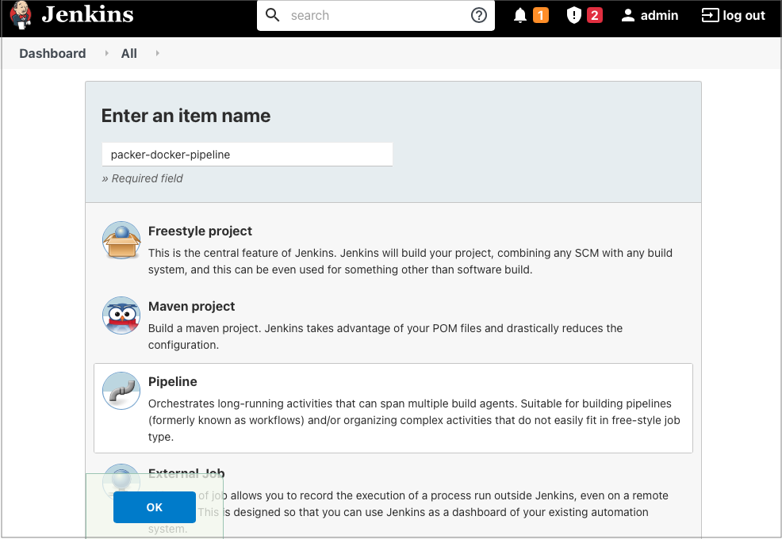

#### Creating Jenkins Pipeline

* On the new Job configuration page, click Pipeline tab and then enter the following values:
  + **Definition:** Pipeline script from SCM.
  + **SCM**: Git.
  + **Repository URL**: https://github.com/fabiogomezdiaz/packer-pipelines.git.
  + **Branch Specifier**: main.
  + **Script Path**: jenkins-tutorial/1-Jenkinsfile.groovy.
  + Click Save.

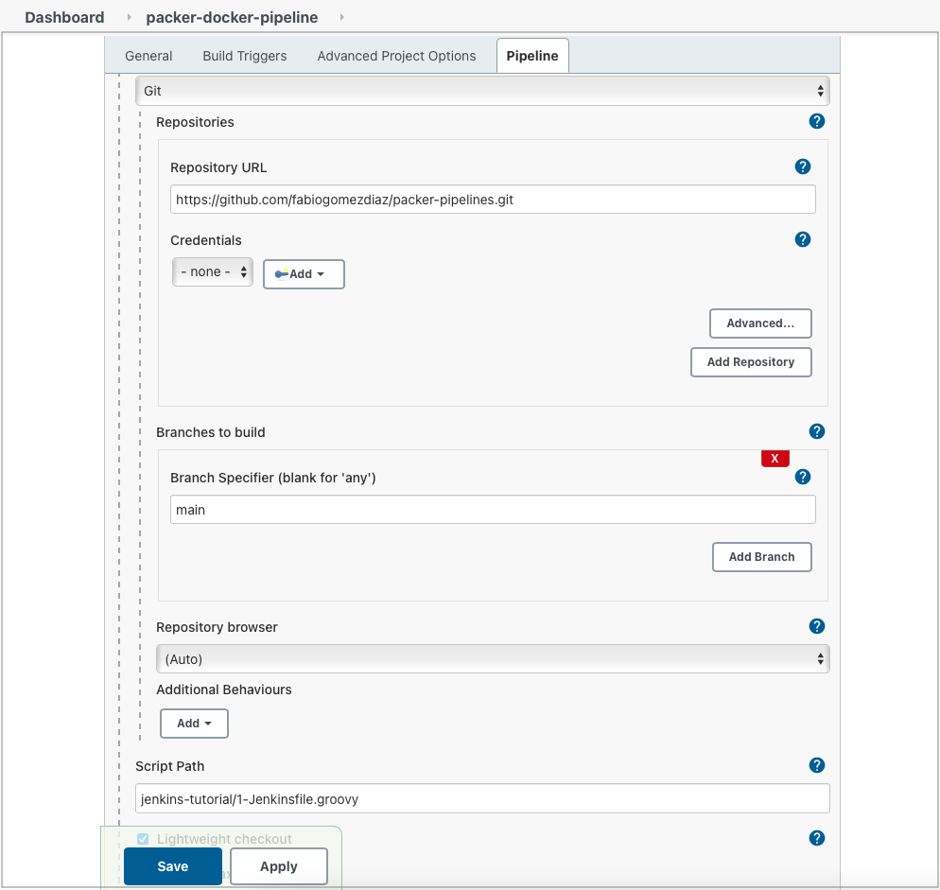

#### Configuring Jenkins Pipeline

### d: Running the Packer Pipeline

Now that everything is ready, go ahead and click on Build Now, to trigger the pipeline.

Then, click the Job Number (i.e. #1), then click on Console Output to see the job logs.

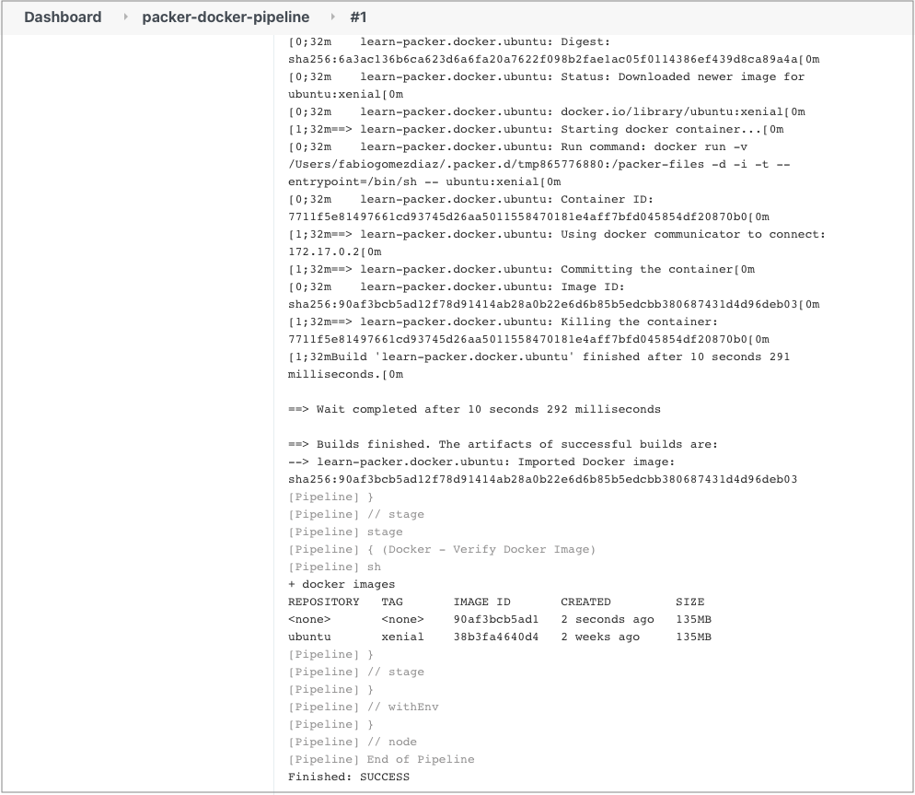

#### Pipeline Logs

If you see the ubuntu image with the xenial tag, as shown above, then, CONGRATULATIONS!!! You have successfully used Jenkins to build a Container Image for Docker using Packer!!!

### e: (Optional) Fix command not found error on Jenkins on macOS

If you are using Jenkins on macOS, you may be getting the packer: command not found or docker: command not found. This means that the PATH variable in Jenkins is not including /usr/local/bin which is where both packer and docker are normally installed.

To fix the error, we need to update the **PATH** environment variable and add the /usr/local/bin folder, which you can do as follows:

* Open Jenkins Dashboard and go to Manage Jenkins -> Configure System
* Scroll Down to **Global properties** and tick the **Environment variables** box.
* Click the **Add** button twice and enter the following environment variables:
  + Variable 1
    - **Name**: USR_LOCAL_BIN
    - **Value**: /usr/local/bin
  + Variable 2
    - **Name**: PATH+USR_LOCAL_BIN
    - **Value**: ${USR_LOCAL_BIN}
* Click Save.

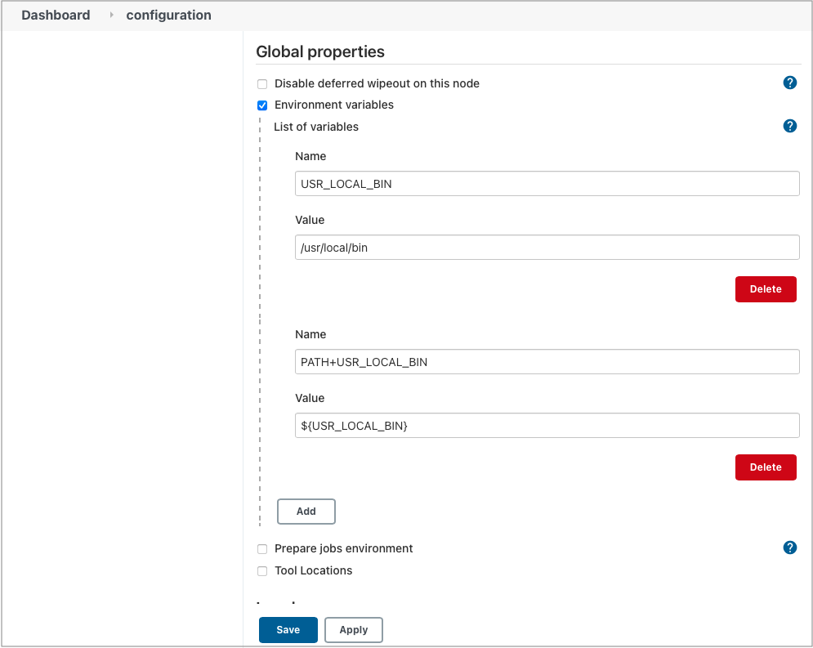

#### Updating PATH Variable

Now, if you try building the pipeline again, the job will be able to find both the packer and docker binaries and be able to run both commands successfully.

## Conclusion

Now that you have setup a Packer Pipeline inside Jenkins, you should be able to write pretty much any Packer code and build images using the pipeline you ran today with minor modifications.

Now, installing and setting up Jenkins and Jenkins nodes is a pretty manual process. If you mess it up, you have start over from scratch, which is a time consuming process. In Part 2 of the **How to Run Packer Pipelines on Jenkins** blog series, we teach you how to deploy Jenkins with Docker, which can save you lots of time and headaches.

* [How to Run Packer Pipelines on Jenkins: Part 2 - Jenkins in Docker](https://fabiogomezdiaz.com/posts/how-to-run-packer-pipelines-on-jenkins-part2-jenkins-in-docker/)